**30th Jan Assignment**

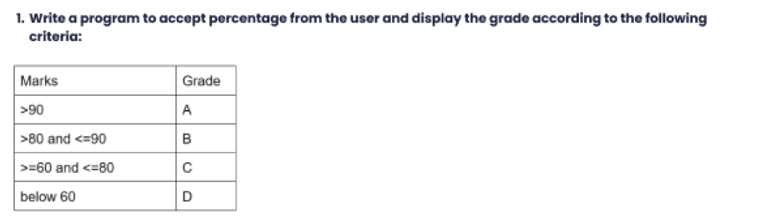

**A)**

student_marks = int(input("Enter the marks percentage:"))

if student_marks>90:

print("Student passed in grade - A")

elif 90>= student_marks >80:

print("Student passed in grade - B")

elif 80>= student_marks>=60:

print("Student passed in grade - C")

else:

print("Student passed in grade - D")

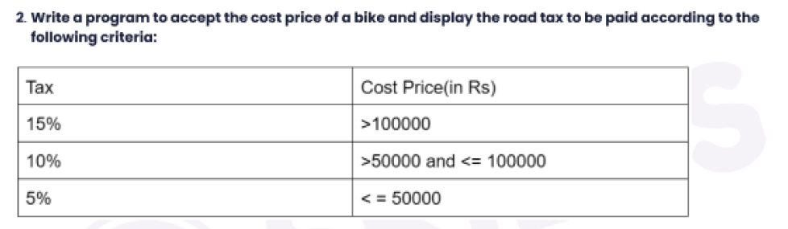

A)

bike_cost = int(input("please enter the cost of the bike:"))

if bike_cost>100000:

print("Total tax to be paid is:",bike_cost*0.15)

elif 50000<bike_cost<=100000:

print("Total tx to b paid is:", bike_cost*0.1)

else:

print("Total tax to be paid is:", bike_cost*0.05)

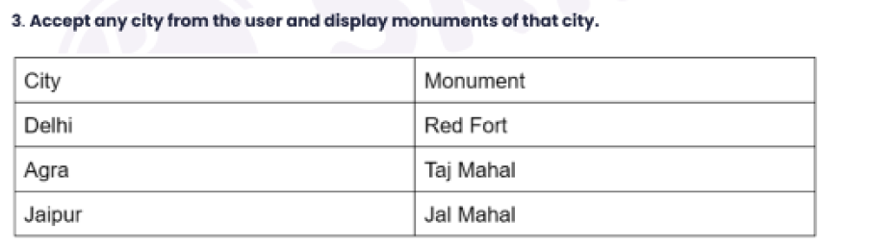

A)

city = input("Enter the city name from the below list \n 1. Delhi \n 2. Agra \n 3. Jaipur \n:")

if city == 'Delhi':

print("You selected city name as {}, coresponding monument Red Fort".format(city))

elif city == 'Agra':

print("You selected city name as {}, coresponding monument Taj mahal".format(city))

elif city == 'Jaipur':

print("You selected city name as {}, coresponding monument Jal Mahal".format(city))

else:

print("select city name from provided list only")



A)

num = int(input("Enter the number to check the count of divisible by 3:"))

count = 0

while num >= 10:

num = num / 3

count += 1

print(count)



A)

A while loop in Python is used to execute a block of code repeatedly as long as a given condition is true. The syntax of a while loop in Python is as follows:

while condition:

# code to be executed

**Example:**

# initialize a counter

count = 1

# condition

while count <= 10:

print(count)

count += 1



A)

**Pattern-1:**

# Pattern -1

rows = 5

i = 0

while i < rows:

j = 0

while j <= i:

print("*", end="")

j += 1

print("\r")

i += 1

**Pattern-2:**

**# Pattern-2**

rows = 5

i = rows

while i > 0:

j = 0

while j < i:

print("*", end="")

j += 1

print("\r")

i -= 1

**Pattern-3:**

# Pattern-3

rows = 5

i = 0

while i < rows:

j = rows - i

while j > 1:

print(end=" ")

j -= 1

j = 0

while j <= i:

print("*", end="")

j += 1

print("\r")

i += 1



A)

Note: Question modified to print 1 – 10 numbers using while loop, since Q7 & Q8 Are same

i= 1

while i<=10:

print(i)

i = i+1



A)

i= 1

while i<=10:

print(i)

i = i+1